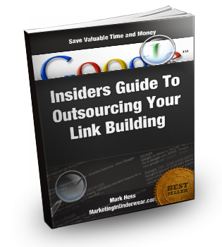

**---------------------------------------------------**

**ALL RIGHTS RESERVED - FOR PERSONAL USE ONLY**

**----------------------------------------------------**

No part of this report may be reproduced or transmitted in any form

whatsoever, electronic, mechanical, including photocopying, recording, or

by any information storage or retrieval system without the informed, written,

dated, and signed consent of the author.

This course is copyright © 2011

The information presented within this ebook solely and fully represents the views of the author as of the date of publication. Any slight to, or potential misrepresentation of, any peoples or companies is entirely unintentional.

As a result of changing information, conditions or contexts, this author reserves the right to alter content or option with impunity. This ebook is for informational purposes only and the author does not accept any responsibility for any liability resulting from the use of this information.

While every attempt has been made to verify the information contained herein, the author and his resellers and affiliates cannot assume any responsibility for errors, inaccuracies, or omissions.

# Introduction

This report will be a little different, because it's hard to recommend specific providers.

No, I'm not hiding any of my top secret, ninja, stealth backlink providers, it's just that things change all the time.

Providers come and go... If you've tried building backlinks yourself, you know how time consuming this stuff is, if these guys aren't making money versus the effort they put in it's time to close up shop.

There are some large companies out there that provide link building services, but they are usually very expensive. And I know for a fact, some of them, simply outsource the work themselves.

I'm going to show you the different ways I find backlink providers . These are going to be some VERY valuable tips, this is the same stuff I use in my business.

Please don't just scan through this, take time to actually read the report.

I know what it's like to purchase something and just scan through it...

I'm going to show you some proven stuff...

Apply it to your business... and profit.

# Some Solid Gold Advice When Selecting Providers



* Look for the little "extras" some link building providers offer. Things such as pinging, submitting RSS feeds, or bonuses. Sometimes, pinging the links and submitting RSS feeds (if done properly) can lead to your links being indexed quicker. Factor these into your decision whether or not to purchase.
* Many times when outsourcing backlinks, people will skip a service offered by people from countries such as Russia or Latvia. Some of the best providers I've hired, come from countries typically frowned upon by many people who do a lot of outsourcing. Link building is a lot different from outsourcing things like graphics, article writing, or web design. Unless you want something very specific done, there's not much communication going on. Most providers simply need to know two things.

1) The URL of your site .

2) The anchor text you would like to use.

* Stay away from people offering services to submit your site to WHOIS directories. It is a complete waste of money and you can do it for free (if you wanted to): <http://www.imtalk.org/cmps_index.php?pageid=IMT-Website-Submitter>

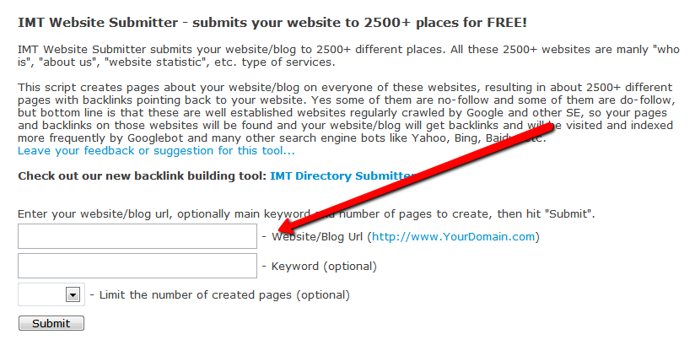

* Get personal with the provider. After placing an order, send an email to confirm everything along with a message stating that you look forward to working with them. This simple message get your work prioritized since they know they're dealing with a real person.
* Stay organized. Document the start/end dates of the project, the website address where you made the purchase, and the URL and anchor text of the links created. Keep all the reports you get back from the providers in a folder.
* Skip the VA's (virtual assistant). This is my own personal opinion, but you can get things done a lot cheaper and faster by using multiple individuals and services versus the same person.
* Take care of your provider. A couple extra bucks goes a long way if you find a provider you feel comfortable dealing with. This could again mean your project gets prioritized. Leave them feedback after a job well done and thank them. Treat good providers like gold.
* Don't be paranoid. Outsourcing at first may seem like a scary proposition. If you've never outsourced links before you can get very paranoid about any adverse effects the links may have on your site/rankings. Stop. If it was that easy to ban/harm sites using links, everyone would use them on their competitors.
* Ask about turnaround time. Not always, but if it looks like the provider is too busy taking care of other people's projects to meet the specified turnaround time, ask first before placing an order to avoid disappointment. This is especially true of new services being offered on forums. Sometimes the provider will get a large initial surge of orders they weren't prepared for. It doesn't mean the service is bad, but there's only so many hours in a day.
* Be consistent and get links built monthly to your sites. You can use a variety of different anchor text, but it's important that inbound links keep getting built. This is less true of local SEO, but if you are competing in a general niche, you will want the links to keep coming. There's no problem with using different providers each month.
* You can't control link indexing. Getting the backlinks built is one thing, getting them indexed is a whole other issue. Sometimes it may take Google some time to "find" the links no matter how much pinging or other tricks you use. Some backlinks are easier to get indexed than others. Be patient.
* Ask for reports. Most providers state that you will be provided with a report after the work is complete. Go through the report, and double check some of the links. If there are a small amount of links being built, all of them should be publically visible (meaning you don't have to login anywhere to see them) and you can check each one to make sure they're all there. If you get a blast of 10,000 links being built, not all of them will be correct. Don't worry about it, when you're dealing with that sort of volume and different site, it's not going to be perfect.
* Test before you go monthly. Never commit to a monthly expense before seeing the quality of work being offered. Ask the provider if they offer a smaller package or test run.
* If you're unhappy, move on. There's no sense getting into a pissing match with a provider. If you're not happy, move onto someone else. Make sure to note the username of the person, their website address, and PayPal address to avoid purchasing from this person again.
* SEO is opinion. That's pretty stupid of me to say since I'm positioning myself as knowing a thing or two about the search engines, but at the end of the day, the only people who truly know Google's algorithm are the people that work at Google. Everyone else is just offering their opinion based on personal experience or testing. Things can always change, look for multiple opinions instead of just listening to one person.
* Other ranking factors. Backlinks are not the only determining factor in search engine positioning. There are a lot of other variables including on-page SEO that when mixed with backlinks can dramatically improve your ranking. Before purchase links, make sure your site is setup to benefit from them. Read up on solid on-page SEO techniques.
* Connect in other ways. Sometimes emails get lost, sent to the spam box, or never replied to. Many providers will offer these ways of additional communication. If a person offers you their Skype, MSN, or Yahoo messager id, use it.
* Look for a detailed description of the service. This is true whenever you are looking for outsourcers, the more vague a person is about what they're doing, the better the chance you're not going to be happy with the results.
* If you can avoid it, never directly send a person money. Always look for a "buy now" button. This will help protect you from fraudulent service providers since you can later file some type of grievance if you're not happy.

# Fiverr Specific Tips

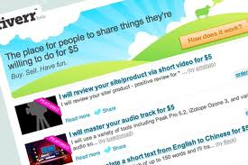You will be hard pressed to find a better, cheaper way to get links than using [Fiverr.com](http://fiverr.com).

Since utilizing the site, I have found a TON of really good providers. But there were also some bad ones. I've learned a lot about doing business as a buyer and how to spot the good opportunities for getting dirt cheap links.

What's awesome about this is that you can tap into some networks and distribution channels people are paying big money for monthly or benefit for software that costs hundreds of dollars, all for $5.

You also have some level of protection. If the service isn't complete in the specified amount of time you get the $5 credited back to your account if you decide to cancel the order:

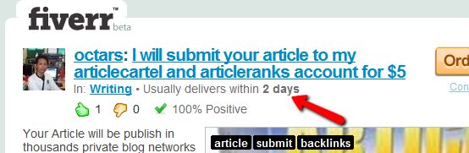

If you have a problem with a seller, click on the "Got Problems" link.

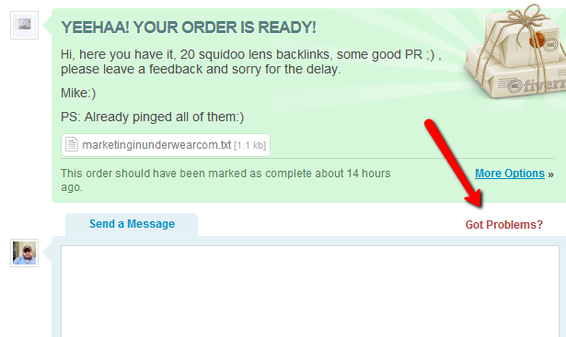

You have several options to resolve issues:

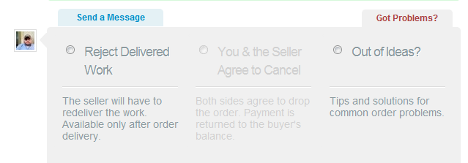

Or you can always contact [Fiverr customer service](http://www.fiverr.com/feedback).

Ok, so here are some great tips so you can crush it buying links on Fiverr...

* Pay attention to the amount of orders the sellers has in their queue. Even if the service has a lot of "thumbs up" and good reviews, it doesn't mean things haven't changed and now the provider is backed up:

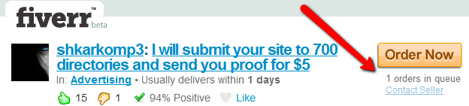

* Shop around before pulling the trigger. Take your time, people are forced to compete with each other on fiverr. Many people will offer the same type of service, just more. Like more links, more comments, etc... for the same amount of money.
* Don't rely on feedback. Feedback on Fiverr can be manipulated and as I said before, things change. You are protected no matter what, so try taking some chances going with providers with limited feedback.
* Buy newer gigs. I've had a lot of success buying newer gigs for services that people just started offering. I think the reason for this is because the seller knows they need positive feedback in order to make more money so they will over deliver when they first start out.
* Take into account when the gig was created and when the last feedback was given (if any) some people will start gigs on a whim, then completely forget about them or no longer offer that service. If you have some doubts going in, use the "contact seller" link to send them a quick message:

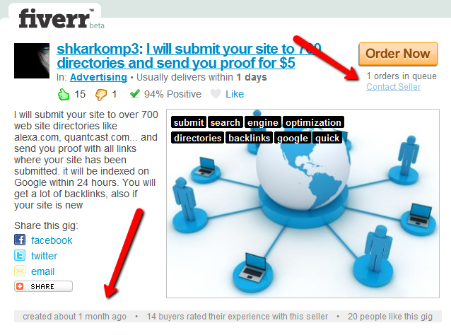

* Search in quotes. If you're looking for a specific set of links to be built, i.e. .edu links, profile links, etc... search for the term in quotes:

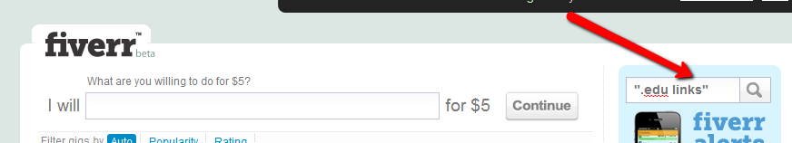

* Don't buy lists or gigs listing "teach" in the title. You're looking for people who offer their services, not lists of sites for auto approval, high PR, etc... unless you plan on putting in the work yourself. Make sure you read carefully to make sure what's being offered is a service and not a list.

# Fiverr Search Terms

These are some of the terms I like to use when searching for link building services on Fiverr.

Obviously these terms will vary depending upon the project. When searching for these terms, use all of these both with quotes, and without....

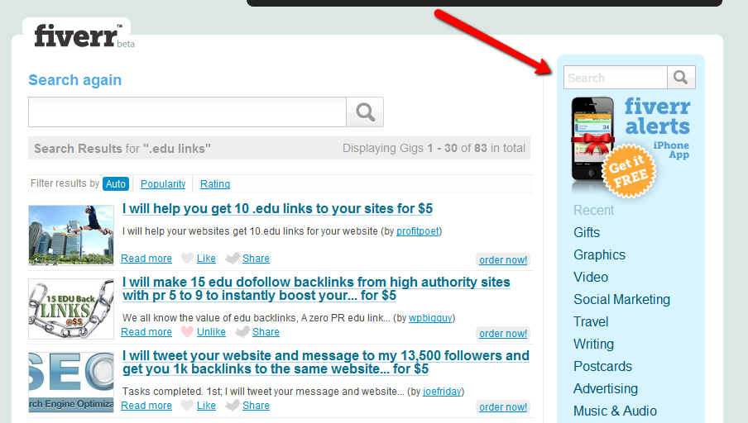"backlinks"

"high pr backlinks"

"blog commenting"

"xrumer"

"profile links"

".edu links"

".gov links"

"press release"

"scrapebox"

"social bookmarking"

"linkwheel"

Remember that new gigs popup all the time so the search results are always changing...

# Warrior Forum Advanced Search

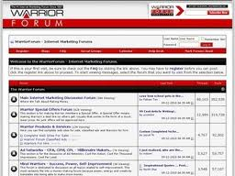Many people will jump at the first sign of a great looking link building service listed on the Warrior Forum.

Sometimes this can be a big mistake and cost you money. I'm going to take you through some of the most effective ways to search the Warrior Forum.

Start by clicking on the "search" link at the top of the forum:

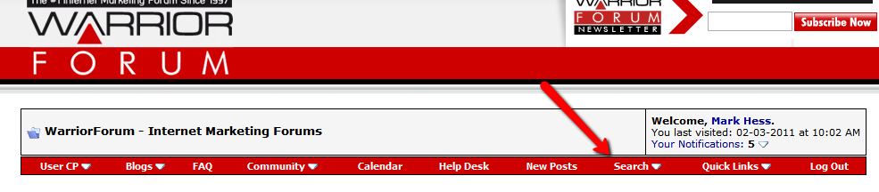

Then clicking on the "advance search" option:

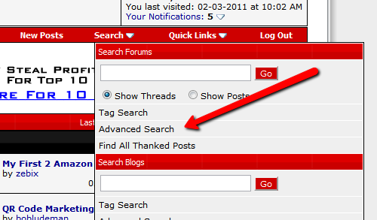

There are two places to look for providers. The WSO forum, and the Warrior For Hire section. You can find some awesome link packages in both...

Enter the search term for the type of link you would like created or just enter a general term in the search box. For more specific results, enter the search term in quotes.

On the right hand side, click on the "Warrior Special Offers Forum", hold down your "Ctrl" key on your keyboard and also click on the "Warriors For Hire" link.

After this is done, click on the "search now" button:

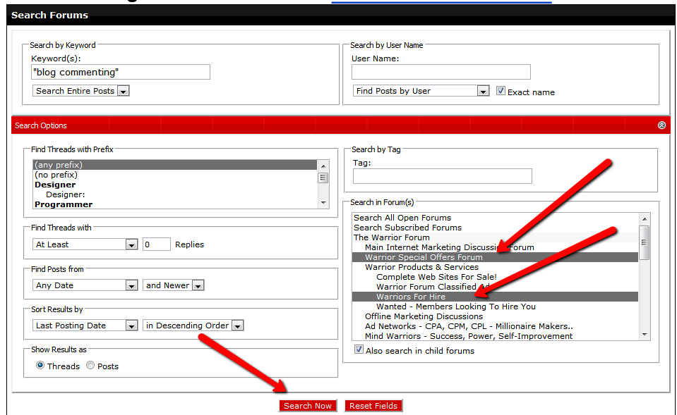

You will only see search results from those two areas of the forum:

# 

Sometimes with using providers from the Warrior Forum, price isn't all that matters.

If a person has a good reputation on the forum, usually the service is legit, and you shouldn't hesitate spending the extra couple bucks.

Please refer to the first section of this report and go through the general tips. They will help you greatly when selecting a provider.

If you have a decent reputation yourself on the forum. Always look out for new services being offered. Many times people will offer reviews copies and you could get some backlinks for free.

It never hurts to ask, both parties involved will benefit. This type of thing is better done through Private Message versus a post on the thread. Don't send this types of requests out to often, but once in awhile doesn't hurt.

**Make sure to also checkout the** [**WickedFire.com**](http://www.wickedfire.com/links-seo/) **forum. They offer a section for links and SEO.**

**The** [**BacklinksForum.com**](http://backlinksforum.com/backlinks-classified-ads/) **also offers classified ads or BFSO's for link building services.**

[**CHECK ON THE STATUS OF BACKLINKS YOU ORDERED FROM PROVIDERS (FOR FREE):**](http://www.scrapebox.com/free-link-checker)

# 

# Types of Links

You need to understand the different types of links that people are offering. Some types of links are better than others in terms of SEO value and some links will get indexed faster than others.

I'm going to run through the types of links I like to get built/

It's always a good idea to get different styles of links built. Link diversity is a good thing, and may lead to higher rankings.

If you can find a reasonably priced service offering .edu or.gov backlink creation, this can make a nice addition to your overall site "portfolio".

# Private Blog Networks

This is one of my favorite methods of getting backlinks...

There are some advantages to using private blog networks for link building.

Your backlinks will typically get indexed a lot faster versus other backlinking methods.

Many of these networks are "looked after" meaning the owner puts in work building links to the actual blog where your post will reside. They may also make sure their pages and blogs are always getting crawled so the backlinks get indexed.

Typically, they work by taking an article, spinning it, then distributing it throughout the network of sites (blogs).

This will give you contextual backlinks or in content text links which are links that placed within content.

Before making a decision whether or not to submit an article to one of these networks, make sure each blog has its own IP address within the network. This will add to the uniqueness of the backlinks.

Look for people offering a private blog network **service** (i.e. - creating/submitting the article for you) versus paying monthly.

You can simply search Google for the term "private blog network" but that would give you a ton of results:

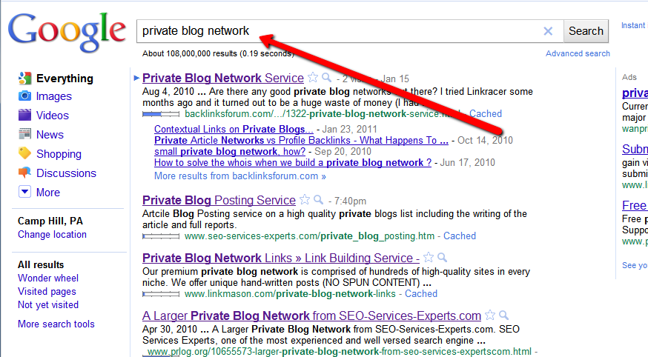

From my experience, to get access to the really "good" private blog networks, they're usually found on forums. Do a search using the following search strings, and you'll be surprised at how many services are around:

site:warriorforum.com [private blog network]

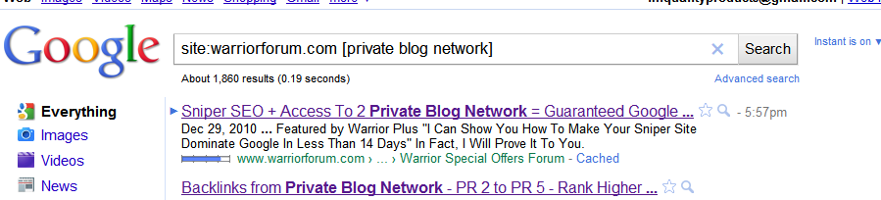

site:wickedfire.com [private blog network]

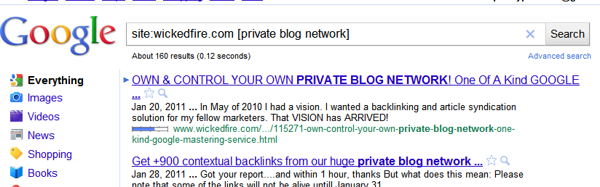

site:backlinksforum.com [private blog network]

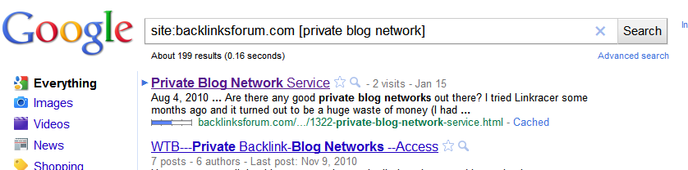

Instead of just looking at the title of the posts in the search results, make sure to check out some of the full forum threads.... gold can be found reading these.

You will also get to read reviews of the services being offered. These should be factored in when deciding if the service is a good fit for you.

If the thread is old (meaning it was posted awhile ago and hasn't had any recent comments) make sure to contact the person offering the service to make sure it's still available.

You can also search [Fiverr.com](http://fiverr.com) and enter the term: private blog network. New gigs will popup from time to time:

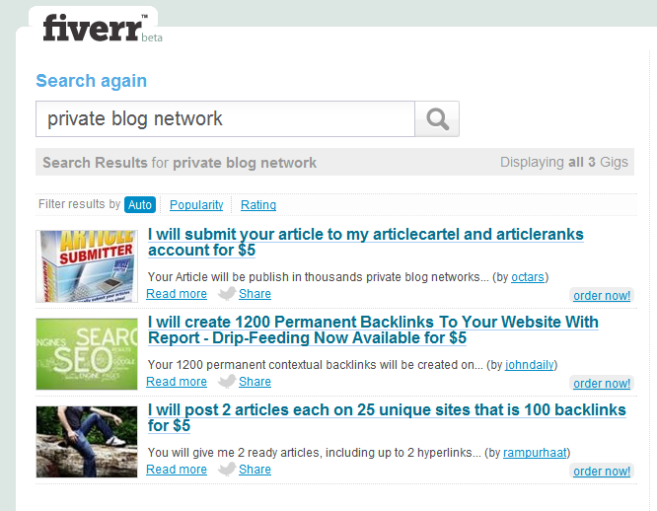

**A great resource for finding some more "main stream" blog networks can be found on the** [**linkvanareviews.com**](http://linkvanareviews.com/) **blog. Check out the categories on the right hand side of the blog.**

# Article Distribution

Anyone who's been around Internet marketing should already know article marketing is a very effective for building backlinks.

Article distribution simply means getting your article distributed to many different article directories.

This is similar to getting content distributed through a blog network, except you're using article directories instead of blogs.

You should spend more time writing articles than distributing them. (Hell, you can even outsource the article writing)

It usually costs a little more, but if you can, go with a service that will both write and distribute you article.

There are a lot of "mainstream" sites that do this for you. Companies or individuals who have their own sites listed and advertised in Google.

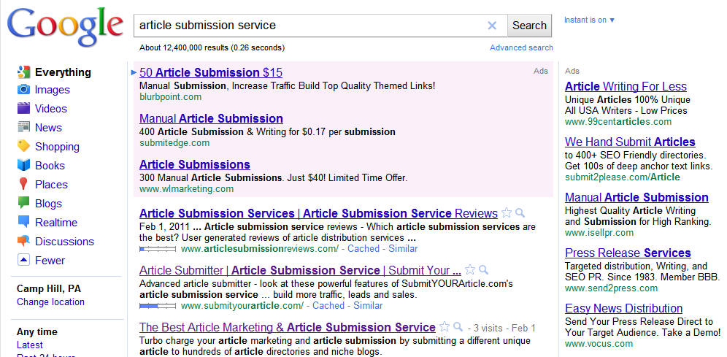

If you go with one of these sites, before purchasing, search around for the name of the website or service to find and read reviews.

Some of these providers are very overpriced and return the same results as other individuals offering the same service.

Always look for guaranteed article acceptance. It's one thing to say they are blasting your articles out to 200 sites, but if only 25 accept your article the service is basically worthless.

When it comes to this kind of service, prices will vary dramatically. Look for the best value.

I find the best value by searching forums....

You can do the same search in Google, for article submission service, but this time use Google's real time search:

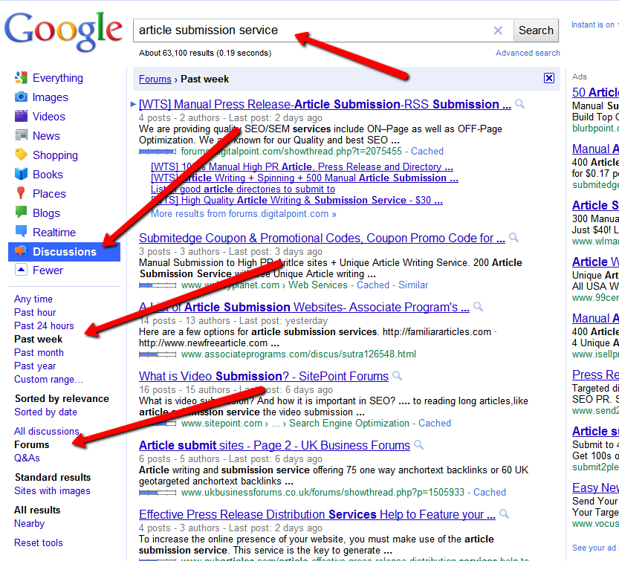

This will pull in results from forums. You can find things like reviews, people offering services, or even coupon codes.

# Social Bookmarking

While social bookmarking isn't as effective as it used to be, anytime I launch a new site, this is one of the first things I get outsourced.

It makes for quick indexing of the site, and also some instant link juice. While social bookmarking can't be considered "traditional" link building, there is still some SEO value there...

It's a great idea to also get your inner content pages bookmarked and not just the main domain. This could mean both a little extra traffic, but more importantly, it provides some "deep linking" value.

I ALWAYS use Fiverr for this, there's always a ton of people offering their service:

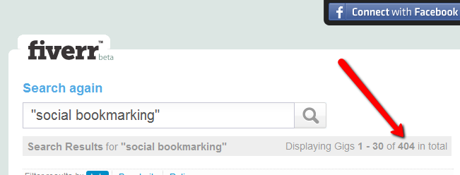

Remember to use some of the [Fiverr.com](http://fiverr.com) tips I told you about earlier.

You can also apply some of the forum search functions I mention, but in terms of price versus service, Fiverr is the way to go for social bookmarking.

Try to find package deals where people will submit multiple URL's for a discounted price. Make sure before committing to a larger package, you test out a smaller one first to make sure you like the service.

# Blog Commenting

Blog commenting is usually offered to be done either manually or with some piece of software.

One of the most popular and effective pieces of software is [scrapebox](http://www.scrapebox.com) for automatically commenting on blogs.

Many times the providers will use an "auto approve list" basically meaning the comments are not being moderated and there is a good chance of your link being posted on that particular blog.

Do not buy any lists of auto approve blogs unless you plan on doing the commenting yourself. The service provider should have a list they're currently using for this service.

Many times the provider will give you an approximate success rate. This should be taken into account, and subtracted from the total amount of comments they're offering.

Comments on high page rank blogs have been proven to have a positive effect on search engine rankings.

These links are also more likely to be indexed in Google.

# Software Service Providers

When a backlinking software appears on the market, read the reviews.

If you like the sound of it, and read positive feedback. Save your money...

People usually start offering services using that particular software. You get all the benefits, without the learning curve.

For instance, let's take SENuke as an example...

Save your $100+ per month and get all the benefits of SENuke without being saddled with the monthly fee.

You can also check forums or Fiverr...

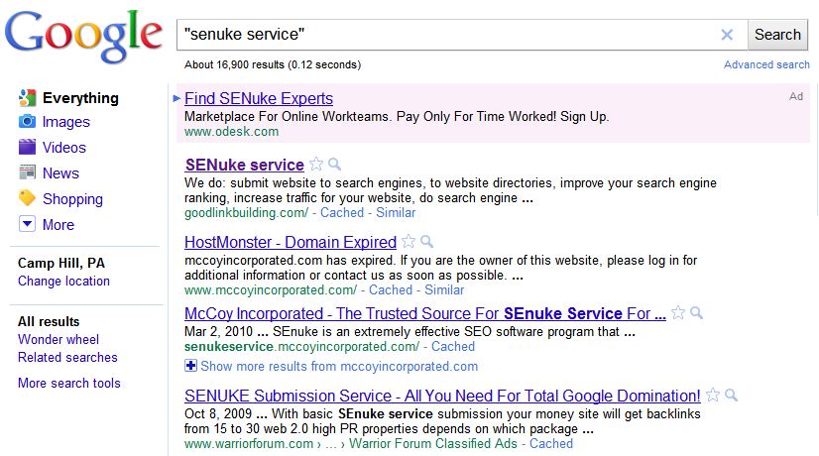

# Forum Profile Backlinks

This is my 100% honest opinion: Stop buying forum profile backlink packets where you have to do the work yourself. The vast majority of them are a complete waste of money and time. Not all of them, but the vast majority.

There are people available to manually create high profile backlinks, but the majority of them use software.

The most common software used to automate the creation of forum profile backlinks is Xrumer.

You may have heard of the software before, many black hat SEO's use the software to create thousands and thousands of links.

The downside to using forum profiles as a method of link building is that you will have a tough time getting the links indexed.

I have found that many times if the forum user profile remains intact (meaning the forum owner doesn't remove the profile) eventually, these will get indexed. But it takes time and you will not see results right away.

The people that build these links using Xrumer typically call them "blasts". So what you'll be ordering is an "Xrumer blast".

I have ordered HUNDREDS of Xrumer blasts over the years so here are some tips when selecting a service:

* Don't overpay for the service. Make sure to look around, and do some searching on Google using looking for the most amount of links, for the least amount of money.
* Ask for a report. Most Xrumer blast providers state they will give you a report when the project is finished. Typically, this will be in .txt format listing the links that where created:

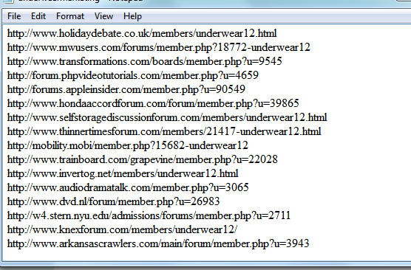

* Don't expect perfection. Not every link will be active or publically available so long as the majority of them are active, the provider did their job.
* Ask about the list. A good provider will always have an updated list of forums. This is important to get the most out of your blast.
* Don't use too many keywords. A big mistake I was making when first starting out was using multiple domain names and keywords for blasts. Many times providers will allow you either multiple domains, or multiple keywords. My blasts started becoming more effective when I was just sticking to one domain and one keyword per blast instead of spacing everything out.
* Look for drip feed. Many times if a provider offers a "drip feed" service, it means they know what they're doing with the software. Even if you don't take them up on the drip feed, order a regular blast from them.

You will typically see people offering two different of xrumer blasts:

1) Forum Profile Links

2) Forum Links or Forum Signature Links

Forum signature links are where the software goes through and posts comments on forums. This is pretty spammy and you're better off staying away from these.

NEVER use the forum signature links for offline clients. It could turn into a disaster with spam complaints and you also have the company's image to consider.

Xremer blasts are available EVERYWHERE... make sure to check out the foums and Fiverr first before going with a site in Google.

You will save a lot of money...

# That's It!

You've reached the end...

I hope you have found my report useful and learned a couple new things you can apply to your business.